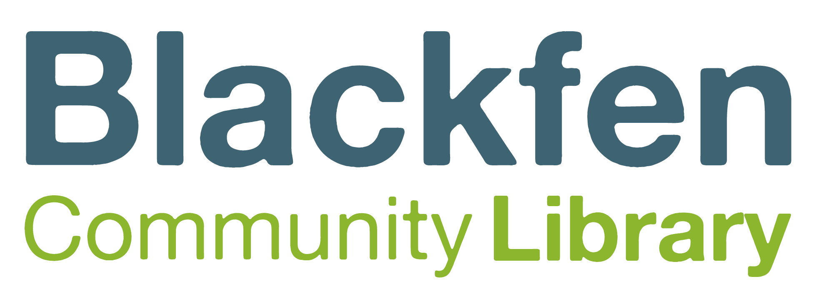
Membership Terms and Conditions
(Including enforcement of overdue items)
Date implemented: November 2021
Date to be reviewed: November 2022

On becoming a member of Blackfen Community Library you agree to the following terms and conditions of membership:
- You are not already a member of Blackfen Community Library
- You will abide by the Library rules and regulations governing the service (e.g. Computer Usage Terms and Conditions)
- You must bring your library card to borrow items
- Library members under 16 years old will need written permission from a parent or guardian to join
- You are responsible for all items borrowed with your library membership card and for any charges resulting from overdue items, hire charges, damage to or loss of items, where applicable
- You will inform Blackfen Community Library of changes to your name, address, e-mail address or other contact details
- You are expected to bring items back on time or renew items – charges will apply for items brought back late (with the exception of members under 16)
- You will pay all charges as they become due
- All communication from Blackfen Community Library to members will be via email where email addresses are provided (e.g. information about overdue and reserved items)
- You will not be able to borrow items if you have outstanding charges above the current limits for which there is no payment plan in place
- All charges for item requests, lost items and lost library membership cards are non-refundable
- Lost membership cards must be reported immediately. You will be held responsible for any items borrowed before the loss is reported
- Proof of address will be required for clarification of identity
- Renewals are not permitted if a reservation has been placed on items you have on loan

Blackfen Community Library reserves the right to refuse an application for membership.
Library members not observing the Terms and Conditions may be restricted in their use of services provided by Blackfen Community Library.
Blackfen Community Library can change these terms and conditions at any time by giving at least 3 months notice of any change via notice boards within the library and on the website. Members who do not wish to accept the change may cancel their membership.

Borrowing
- Children and adults can borrow a maximum of 10 books for three weeks.
- All items can be renewed up to three times but requested items cannot be renewed.
- To renew library items you can access our Reading Cloud 24 hours a day via the link on our website or you can visit or telephone Blackfen Community Library during opening hours.

Enforcement of overdue/non-returned items:
- All Library materials borrowed must be returned within the stipulated loan period. Failure to do so will result in application of the following sanctions:
- Overdue charges: 35p per day for adult books, no charge for children's books
- After 7 days the borrower will receive a reminder email that the items are still overdue
- After 14 days the borrower will receive a second reminder email
- After 28 days the borrower will be suspended. The borrower will need to pay the fines or arrange a payment plan in order to reactivate their account.
- If the overdue book is a children’s book then the responsible adult will be contacted to request payment for the replacement value of the book.
- Where an item is lost or stolen, returned damaged, or not returned after a reasonable period of time, the borrower will be charged for the cost of replacing the item. The customer may alternatively provide a new replacement copy. An item charged for in this way remains the property of the Library.
- Failure to observe any of the foregoing provisions may, in the first instance, be dealt with by the Library Manager, who may take such action or apply such penalty as is reasonable in the circumstances.

Cost of replacement cards
- Adults: £3.50.
- Under 16s: first replacement card is free, subsequent cards cost £1.

Computers
- Computers are free to use. They all have an internet connection, and free wifi is also available in the Library. There is a time limit of 30mins if anyone is waiting.

Printing and Photocopying
- USB devices can be used at your own risk
- Printing is available, charges are:
Black and white - A4 sheet 20p, A3 sheet 30p.
Full colour – A4 sheet 30p, A3 sheet 40p.

Laminating
- Laminating is available. Charges are: A4 sheet 50p, A3 sheet £1.

Scanning
- 20p per sheet but concessionary prices for large volumes.

