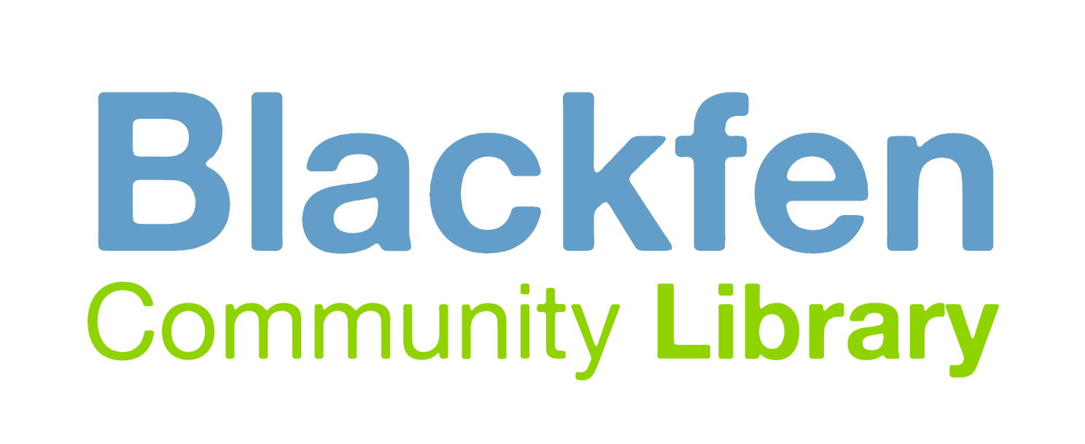
Hiring Policy – Venue Use

- Blackfen Community Library allows for the Meeting Room and wider library spaces to be used for Business or Community Group or Individual use.
- The final decision on user suitability lies with the Library staff. It may not always be possible for businesses, groups or individuals to use the library spaces.
- This policy only relates to occasional use of library space, although it does allow regular bookings for limited periods if arranged with Library Staff.

The spaces can be hired for one-off events or for regular events. The Main Library and Coffee House Café Area are available for hire outside of the Library Opening Hours. The Meeting Room and Community Space are available during Library Opening Hours. Bookings can be made by filling in an enquiry form on the Blackfen Community Library Website, paying a deposit and agreeing to the Terms and Conditions.

Price Guide

See Library Website for up-to-date prices for each of our spaces for Hire. Prices for Hires longer than an hour or for regular bookings will be made at the discretion of the Library Staff.

Additional costs

Hospitality for meetings can be arranged - please speak to the library staff to book.

Other information

- All bookings require a £20 non-refundable deposit (which will be taken from your final amount due).
- For the Meeting Room an upfront non-refundable payment of £5 will be required to reserve your hire on booking being confirmed.
- Events that overrun and/or leave the facility messy and untidy may lose their deposit and further charges may be made depending on the circumstances.
- Full payments must be made in advance or on the day. If for some reason a group wishes to cancel their booking, they must give 7 days notice, otherwise they may be charged the hourly rate equal to the duration of the booking.
- It is possible that some businesses would be required to have Public Liability Insurance for the activities they run. If insurance is required for your hire please inform Library Staff when a hire request is made.
- The Terms and Conditions Document must be read and agreed to on the Website before use of the venue.
- We reserve the right to cancel bookings if necessary due to unforeseen circumstances or for health and safety reasons. We will provide as much notice as possible including a refund of any deposits paid.

How to Book

Businesses/Individuals should:

- Complete the Booking Enquiry on the Library Website:
https://blackfencommunitylibrary.org/venue-hire/

- Once the Booking Date is agreed, Hirers must:

  - Pay a £20 non-refundable deposit
  - Read and Agree the Terms and Conditions
  - Supply a copy of insurance documents (if necessary)

- Pay for the room and any other necessary charges either in advance or on the day.

- On the day of the Hire, meet Library Staff at the agreed time. At the end make sure all furniture/equipment is returned to it’s usual position and tidy and hoover as agreed with Library Staff.

